**MATERIAL, STOCK & DELIVERY RESTRICTIONS**

**MR_Purpose:**

* Consider a scenario in which OUP doesn’t want to supply the books to few continents or few countries. To avoid customers from specific regions/countries/continents, a profile will be created with conditions to restrict the sales to that region & to that profile, the required materials will be assigned. As a result, customers from those regions will not be able to create a order for those materials and will be rejected with Reason of rejection as ‘Market restricted’

**DR_Purpose:**

* For Situations, where OUP allows order creation from specific regions/countries/continents for a specific title but has to reviewed it before delivery creation whether to allow or not, Delivery restrictions is used by placing the delivery block at the line item level.

**SR_Purpose:**

* For scenarios, where OUP wants the titles to be consumed from Specific storage location in a plant for a set of users from specific regions/continents/countries, Stock restrictions is being used by mentioning the storage location from which titles are to be used.

**Pre-requisite:**

* Profile setups
* Material-profile assignment

**Tables used:**

* ZOTC_PRO_PAYER: Contains the payer mapped with the profiles along with the restriction flag as ‘R’ indicating the restrictions 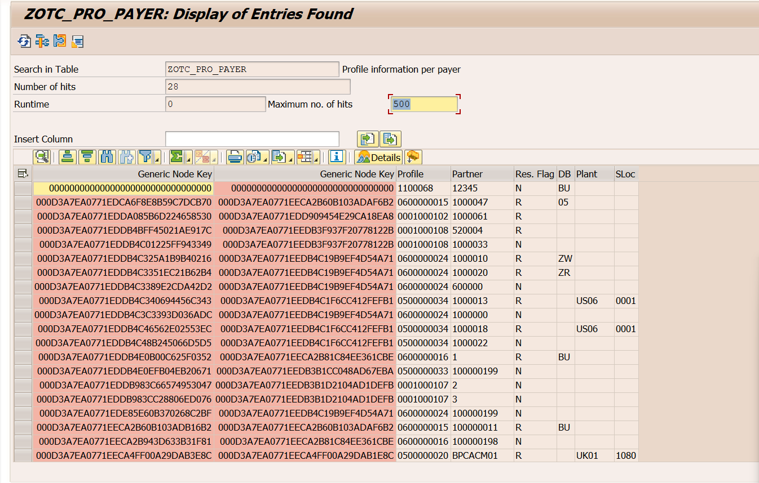
* ZOTC_PRO_SALES: Contains the sales district mapped with the profiles along with the restriction flag as ‘R’ indicating the restrictionsA screenshot of a computer

  Description automatically generated
* ZOTC_MAT_PROFILE: Contains the Materials mapped with the profiles along with the validity dates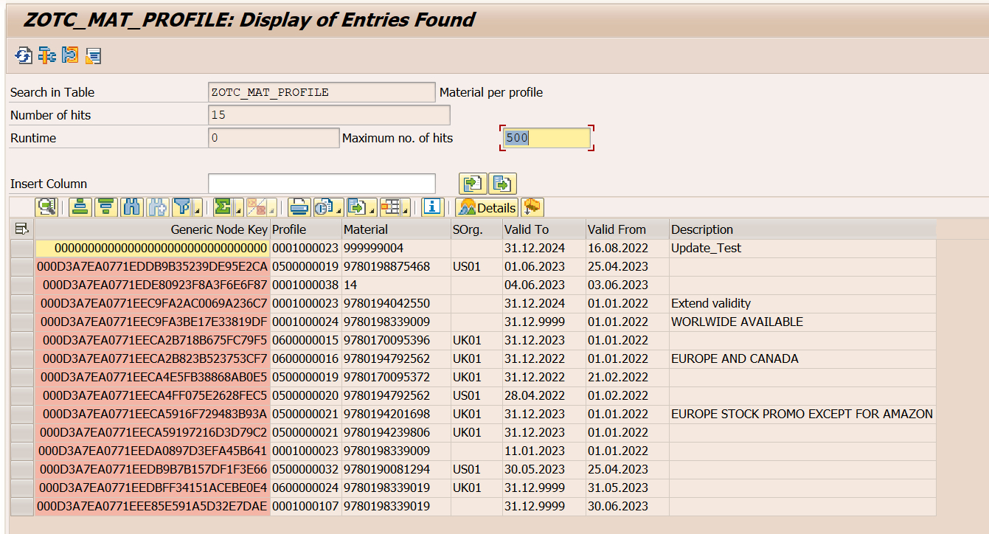

**Applications:**

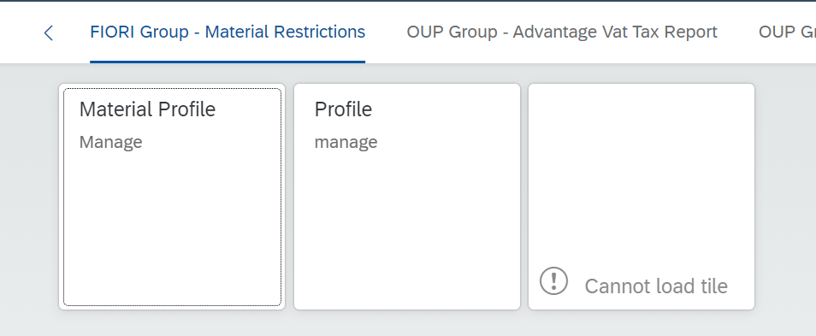

Profile application:

* This application is used to define a profile
* The profile can be MR profile, SR profile & DR profile
* Each profile will have 4 conditions that can be used for restrictions:
  + Restricted sales district – Sales district that need to be restricted
  + Unrestricted sales district-- Sales district that need not be restricted
  + Restricted payer-- Payer who needs to be restricted
  + Unrestricted payer— Payer who need not be restricted

Material-profile application:

* A screenshot of a computer

  Description automatically generatedUsed to assign materials to the profiles

Mass upload:

* Used to do material-profile assignment with the validity dates in mass

**Testing/Setup for MR:**  
 Profile: 0001000107

Material: 9780198339019

Bp: 100000199

Order: 14257

1. **Restricted Sales district(GB001):**

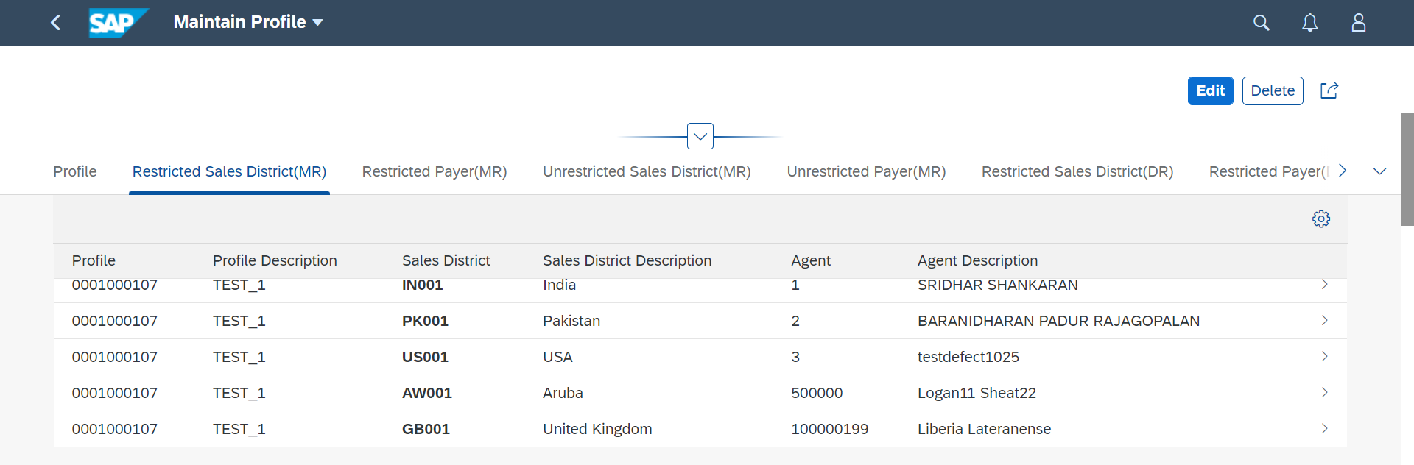

Market restriction pop-up come up as expected.

1. **Restricted Payer(100000199):** **A screenshot of a computer

   Description automatically generated**

Pop-up come as expected.

1. **Unrestricted sales district(GB001):** **A screenshot of a computer

   Description automatically generated**

Pop-up didn’t come as expected

1. **Unrestricted Payer(100000199):**

Pop-up didn't come as expected.

**Testing/Setup for DR:**  
 Profile: 0600000024

Material: 9780198339019

Bp: 100000199

Order: 14257

1. **Restricted Sales District(GB001):** A screenshot of a computer

   Description automatically generated

Delivery blocked as expected

1. **Restricted Payer(100000199):** **A screenshot of a computer

   Description automatically generated**

Delivery blocked as expected

1. **Unrestricted Sales District(GB001):** **A screenshot of a computer

   Description automatically generated**

Delivery did not get blocked as expected

1. **Unrestricted Payer(100000199):** **A screenshot of a computer

   Description automatically generated**  
   Delivery did not get blocked as expectedA screenshot of a computer

   Description automatically generated

**Testing/Setup for SR:**

Material: 9780198339019

BP: 100000199

Profile: 0500000033

Order: 13744

Storage location getting over-written as expected for line item-50

Storage location getting over-written as expected for line item-60

**Scenario3: Unrestricted Sales district**

Storage location id not over-written as expected for line-item 70

Storage location is not over-written as expected for line-item 80

**SIT2-220:**Test data for MR:  
Profile: **0001100011**

Material: 9780192616302

Order:

1. **Restricted Sales District(JP001):**  
   Restriction pop-up comes up as expectedA screenshot of a computer

   Description automatically generated with medium confidence
2. **Restricted Payer(0001100011):**

